ASSIGNMENT -2

- Create registration page in html with username, email and phone number and by using POST method display it in next html page.

App.py

from flask import Flask, render_template,request
app = Flask(__name__)
@app.route('/')
def home():
return render_template('register.html')

@app.route('/confim', methods = ['POST', 'GET'])

def login():
if request.method== 'POST':
u = request.form.get('user')
em = request.form.get('email')
n = request.form.get('no')
return render_template("regsuc.html",name=u,email=em,no=n)

if __name__ == '__main__':
app.run(debug=True)

register.html
<html>
<head>
<title>Registration</title>
</head>
<body>
<center>
<fieldset style="width:500px; height:300px; aglin:center;">
<legend>Register</legend>
<form action="/confim" method="post">
<br><br>
<label>User Name</lable>&nbsp;&nbsp;&nbsp;&nbsp;&nbsp;
<input type="text" name="user" >
<br><br><br>
<label>Email</lable>&nbsp;&nbsp;&nbsp;&nbsp;&nbsp;&nbsp;
&nbsp;&nbsp;&nbsp;&nbsp;&nbsp;&nbsp;&nbsp;
<input type="email" name="email" >
<br><br><br>
<label>Phone Number</lable>
<input type="text" name="no" >
<br><br><br>
<p><center><input type="Submit" value="REGISTER"/></center></p>
</form>
</fieldset>
</center>
</body>
</html>
Regsuc.html
<html>
<head>
<title>Register success</title>
</head>
<body>
<center>
<h1>Registeration success</h1>
<table border=1 style="width:500px; height:100px;">
<tr>
<td>User Name</td>
<td>{{name}}</td>
</tr>
<tr>
<td>email</td>
<td>{{email}}</td>
</tr>
<tr>
<td>Phone Number</td>
<td>{{no}}</td>
</tr>
</center>
</table>
</body>
</html>

Output:

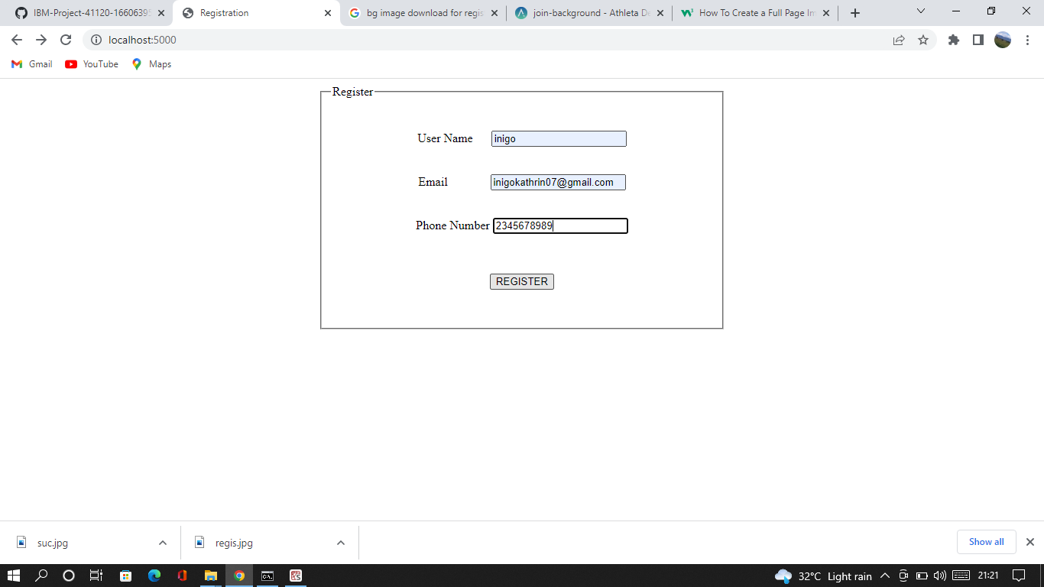

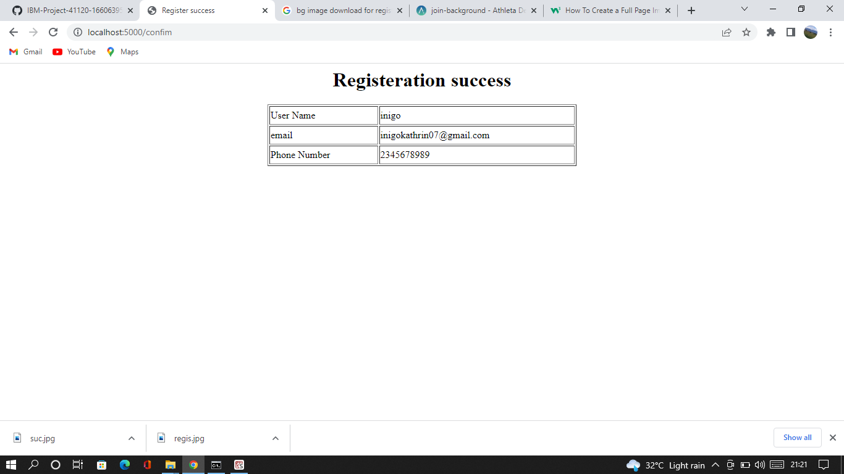

- Develop a flask program which should contain atleast 5 package used from pypi.org.

Pypi.py
import camelcase
from jinja2 import Template
import requests
from flask import Flask
import datetime
import numpy as np

#numpy
arr = np.array([1, 2, 3, 4, 5])
print(" NUMPY ")
print(arr)
print(type(arr))
print("\n")

#datetutil
print(" DATEUTIL ")
now = datetime.date.today()
print(now)
print("\n")

#requests
r = requests.get('https://api.spotify.com/')
r.status_code
print(" REQUESTS ")
print(r.headers)
print("\n")

#jinja2
template = """hostname {{ hostname }}"""
data = {"hostname": "core-sw-waw-01"}
j2_template = Template(template)
print(" JINJA2 ")
print(j2_template.render(data))
print("\n")

#camelcase
c = camelcase.CamelCase()
txt = "lorem ipsum dolor sit amet"
print(" CAMELCASE ")
print(c.hump(txt))
print("\n")

Output:

